](https://www.nsc.org/road/distracted-driving-awareness-month/ddam-materials?)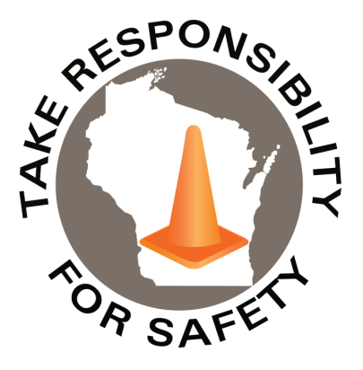

In This Issue:

**Distracted Driving Awareness Month**

**Tornado & Severe Weather Awareness Week**

Volume 12, Number 4

April 2025

|  |
| --- |
| Safety Net(work)  Produced by Department of Administration Bureau of State Risk Management  Produced by Department of Administration Bureau of State Risk Management |

Safety Spotlight:

[Distracted Driving Awareness Month](https://www.nsc.org/pages/ddam/ddam-materials)

](https://www.nsc.org/road/distracted-driving-awareness-month/distracted-driving-quiz)

[Take the New Distracted Driving: Myth vs. Fact Quiz](https://www.nsc.org/road/distracted-driving-awareness-month/distracted-driving-quiz)

[Severe Weather and Tornado Safety](https://readywisconsin.wi.gov/be-informed/tornadoes/)

|  |  |  |
| --- | --- | --- |
| |  | | --- | | **April is Distracted Driving Awareness Month**  Each April, the National Safety Council, USDOT and others observe Distracted Driving Awareness Month to bring attention to the dangers of distracted driving and share simple steps drivers can take to avoid it. This year, [NSC is offering a variety of free resources](https://www.nsc.org/road/distracted-driving-awareness-month/ddam-materials?) to help keep yourself and others safe on the road, including:   * [**A participant guide**](https://www.nsc.org/getmedia/aaaf8f17-a738-473c-93c0-5b117abc5c61/2025-ddam-participant-guide.pdf) to help make your plan for the month * [**The Just Drive pledge**](https://www.nsc.org/faforms/ddam-pledge) to drive distraction-free * Posters, videos and articles on how to prevent distractions, and more * [Distracted Driving Awareness Month Expert Panel](https://nsc-org.zoom.us/webinar/register/WN_a5iepu7JR_2KaStI-og_iA#/registration) (Do you have questions about distracted driving, its impact on road users inside and outside of vehicles, or what you can do to prevent it? All are welcome to join to learn from a panel of experts on the latest findings and how to reduce the risks to keep everyone safe. Become part of the solution to end the unacceptable and preventable distracted driving crashes). | | Hundreds of thousands of people are affected by distracted driving crashes each year. Watch and share [this new video](https://www.youtube.com/watch?v=KwR_D4TOZiE) featuring the stories of survivors and advocates to help people understand the impacts of distracted driving (Ctrl click image to play video from NSC web site): | |

[Distracted Driving is Preventable: Help Create Safer Roads for Everyone](https://www.youtube.com/watch?v=KwR_D4TOZiE)

This month, and any month, please join NSC to help protect your workforce on and off the job, reinforce your commitment to safety in your community, and help create safer roads for us all. To get started visit distracted driving prevention resources such as [National Safety Council](https://www.nsc.org/road/distracted-driving-awareness-month/ddam-materials?) or [Network of Employers for Traffic Safety](https://r20.rs6.net/tn.jsp?f=001lA_Er2Vph8VPaAZuoqGAxPb_3UWw0hhlk7nO0OXxPVJ-wOTxi_ihQJXn6uI41sTi8GTp_g3vHyYAeBA0gdK4MTQXt4AR8uxDLLPfe5o94xBY3C5HdS68_t_JFgJxs4GF_9p1FoX1rYVRMTcqR5wkFt27qZMmmuK2Nk0wnTo0khVJx8eVNnPoNlzbhZ73nRM7xOfo11spwP8Eyfm_w7zsBg==&c=Ukexv6-BX6jsQUdC44KLCBGdTjjHTRBJVnct4U4YGu8W_m18lBJr4Q==&ch=xqa9LndACibAAxZlQwe0JCqOXqVjuimVnTObUwzmlwOrgDuANXgjcA==) .

378

1,607

Claims

FY25 YTD

Workers Comp

Five Minutes for Safety:

384

Claims

FY24 YTD YTD

Lost Time

FY25 YTD

Lost Time

FY24 YTD

1,529

**Tornado & Severe Weather Awareness Week**

Our partners at Wisconsin Emergency Management would like to announce that Tornado and Severe Weather Awareness Week in Wisconsin will take place April 7-11 this year. This annual campaign encourages everyone in Wisconsin to prepare for the tornadoes and severe storms in the state that may develop during the spring and summer months. This is also a good opportunity for all to review their severe weather safety procedures by participating in statewide tornado drills at 1:45 p.m. and 6:45 p.m. on Thursday, April 10th. For more information regarding the 2025 Wisconsin statewide tornado drill, click on the link below!

***Click on the link for more information on the 2025 Wisconsin statewide tornado drill!*** <https://readywisconsin.wi.gov/be-informed/tornadoes/>

[***Tornado and Severe Weather Safety: How can you be prepared?***](https://readywisconsin.wi.gov/be-informed/tornadoes/)

Wisconsin averages 23 tornadoes a year (2024 was the third highest documented number of tornadoes in Wisconsin history with [45](https://www.weather.gov/mkx/wisconsintornadoes)). Peak tornado season in Wisconsin is April through August, but it is important to understand that a tornado can occur at any time of the year. Tornadoes can lead to fatalities and devastate communities in a matter of seconds. This violent force of nature can occur at any time of day or night and may not always be visible.

***By preparing, planning, and practicing how and where you will take shelter could save your life!***

***Important Terms Used During a Tornado: Tornado Watch vs. Warning***

* **Tornado Watch: Be Prepared!** An alert issued when weather conditions in the area favor the formation of tornadoes-often during thunderstorms. Be ready to act quickly if a warning is issued or you suspect a tornado is approaching.
* **Tornado Warning: Take Action!** A tornado has been sighted or indicated by weather radar. This is imminent danger to life and property. Move to an interior room on the lowest floor of a sturdy building. AVOID WINDOWS.

*IMPORTANT NOTICE - The information presented in this newsletter is intended for internal State of Wisconsin agency consideration in loss prevention efforts. Due to space limitations, may not always be all-inclusive in identifying all material associated with topics discussed. It is encouraged to adjust the contents to fit the specific audience of your operation.*

](https://www.weather.gov/images/mkx/tornadoes/2024WiTorEvents2.jpg)[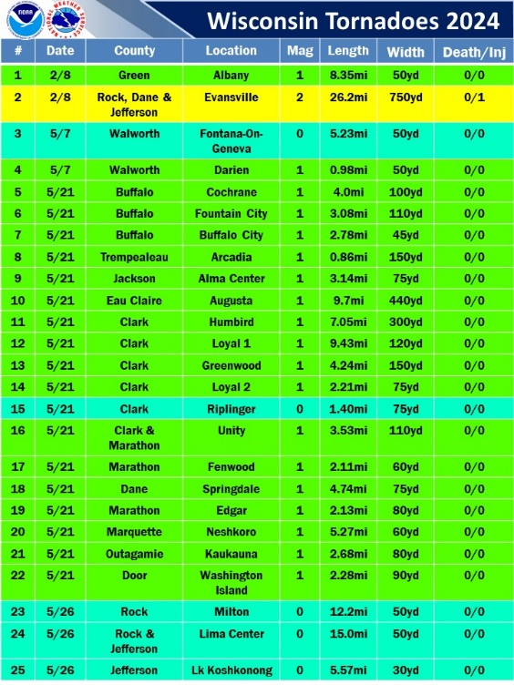](https://www.weather.gov/images/mkx/tornadoes/2024WiTorEvents.jpg)[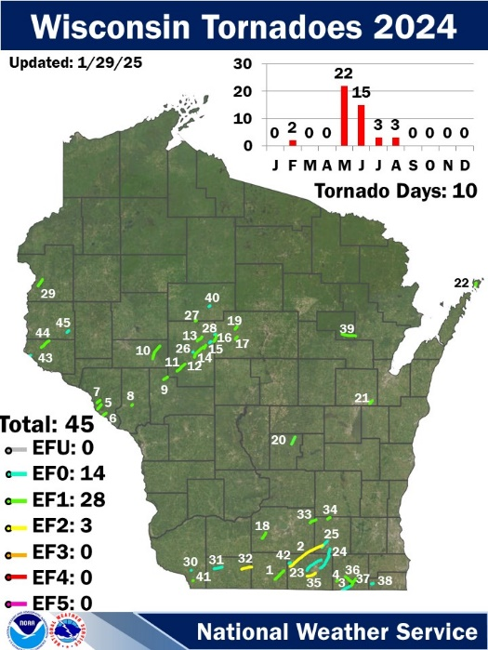](https://www.weather.gov/images/mkx/tornadoes/2024tor.jpg)

***Severe Weather Safety Tips: Thunderstorms and Tornadoes***

* Listen to the radio, television, or weather alert radios for updates.
* When a thunderstorm threatens, go inside a home or large building.
* During a thunderstorm, avoid using telephones, except for emergencies.
* During a tornado warning, TAKE ACTION IMMEDIATELY. Stay away from windows, doors, and outside walls.
* Seek shelter in the basement or an interior part on the lowest level.

Consumer Safety

[United States Consumer Product Safety Commission](http://www.cpsc.gov/)

Contact Us

<https://doa.wi.gov>

E-Mail

[Jake.Lowell@Wisconsin.gov](mailto:jake.lowell@wisconsin.gov)